REDCap logo 

COVID Employee Exposure Tracking

**Starting a New Investigation**

**FIRST, ADD THE NEW EXPOSURE EVENT**

1. Click **Add/Deactivate an Exposure Event** 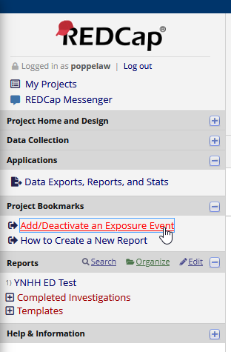
2. Fill out the form with the new **Event Label** and submit

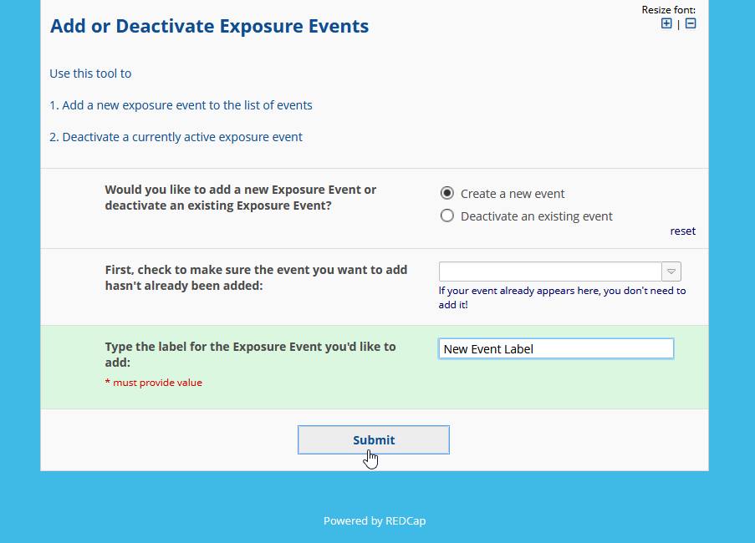

**NEXT, CREATE A REPORT FOR THE NEW EVENT**

1. 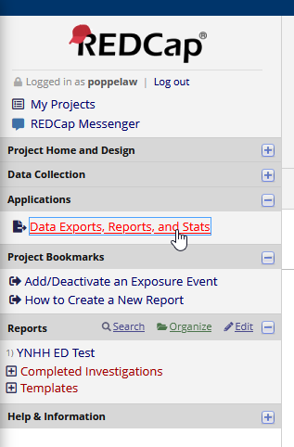Back in the COVID Exposure Tracking project, click **Data Exports, Reports, and Stats**
2. Find the **REPORT TEMPLATE** report and click **Copy**



1. Find the copy you just made and click **Edit**



1. Change the report title to match the **Event Label**

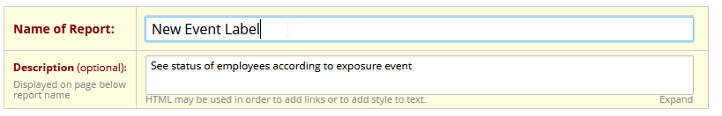

1. Select the new **Event Label** for **Filter 1**

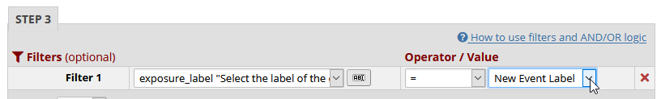

1. Click **Save Report**!

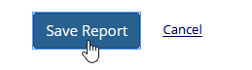

**LAST, SEND OUT THE LINK TO THE MANAGER(S)**

1. Make sure to include the PDF Tip Sheet and the new **Event Label**!